𝐃𝐞𝐯𝐞𝐥𝐨𝐩𝐞𝐫𝐬𝐇𝐮𝐛 𝐂𝐨𝐫𝐩𝐨𝐫𝐚𝐭𝐢𝐨𝐧 𝐢𝐧𝐭𝐞𝐫𝐧𝐬𝐡𝐢𝐩 𝐩𝐫𝐨𝐠𝐫𝐚𝐦
DHC - 2384
Syed Muhammad Hamza Mehdi
2026
SECTION 1 — Week 4:
1.1 Rate Limiting Implementation
Tool/Library: express-rate-limit
File: middleware/rateLimiter.js

Three rate limiters implemented:
- generalLimiter: 100 requests per 15 minutes on all routes
- loginLimiter: 5 login attempts per 15 minutes (brute force protection)
- apiLimiter: 30 API calls per minute for API endpoints

When limit is exceeded:
- HTTP 429 (Too Many Requests) returned to client
- Security event logged with IP address and timestamp
- Login attempts also log the email being targeted

Test Result: After 5 login attempts, the 6th request was blocked
with a 429 response and the event was recorded in security.log
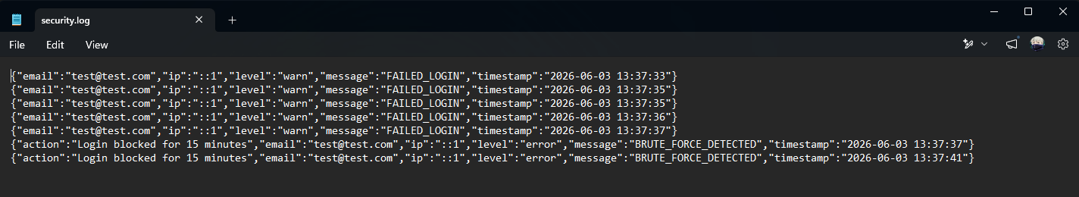
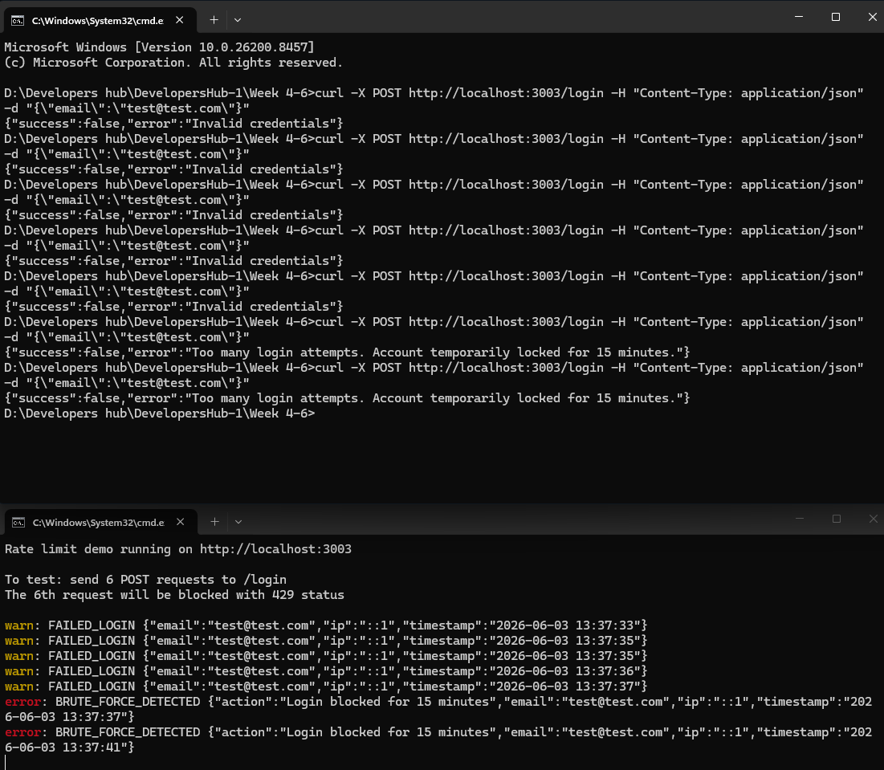
Security Impact: Without rate limiting, an attacker can attempt
thousands of password combinations per minute. With loginLimiter,
they are restricted to 5 attempts per 15 minutes, making brute
force attacks practically infeasible.

1.2 CORS Configuration
Tool/Library: cors
File: middleware/corsConfig.js

Implementation:
- Whitelist of allowed origins defined explicitly
- Requests from unlisted origins are blocked and logged
- Credentials handling configured
- Preflight cache set to 24 hours for performance
- Separate strict CORS config for sensitive API routes

Before Fix: All origins accepted — any website could make
requests to the API on behalf of users
After Fix: Only whitelisted origins allowed — unauthorized
cross-origin requests blocked and logged
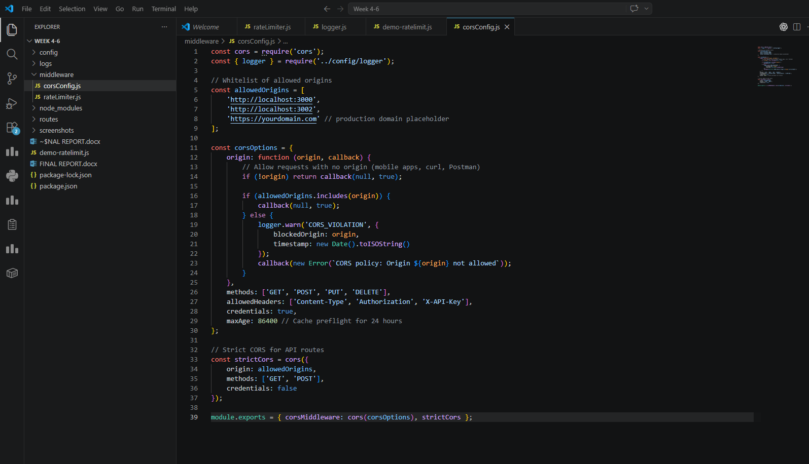
1.3 API Key Authentication

File: middleware/apiKeyAuth.js

Implementation:
- API keys generated using Node.js crypto module (cryptographically secure)
- Keys passed via X-API-Key request header
- Each key has defined permissions (read/write/delete)
- Missing or invalid keys return 401/403 with logging
- Keys never fully logged — only first 10 characters stored in logs

Key Format: ak_845828cf75d884e9c3b2ecbc1888ebe54efd505e1f60ed9c= 192 bits of entropy
This makes brute force guessing computationally impossible.

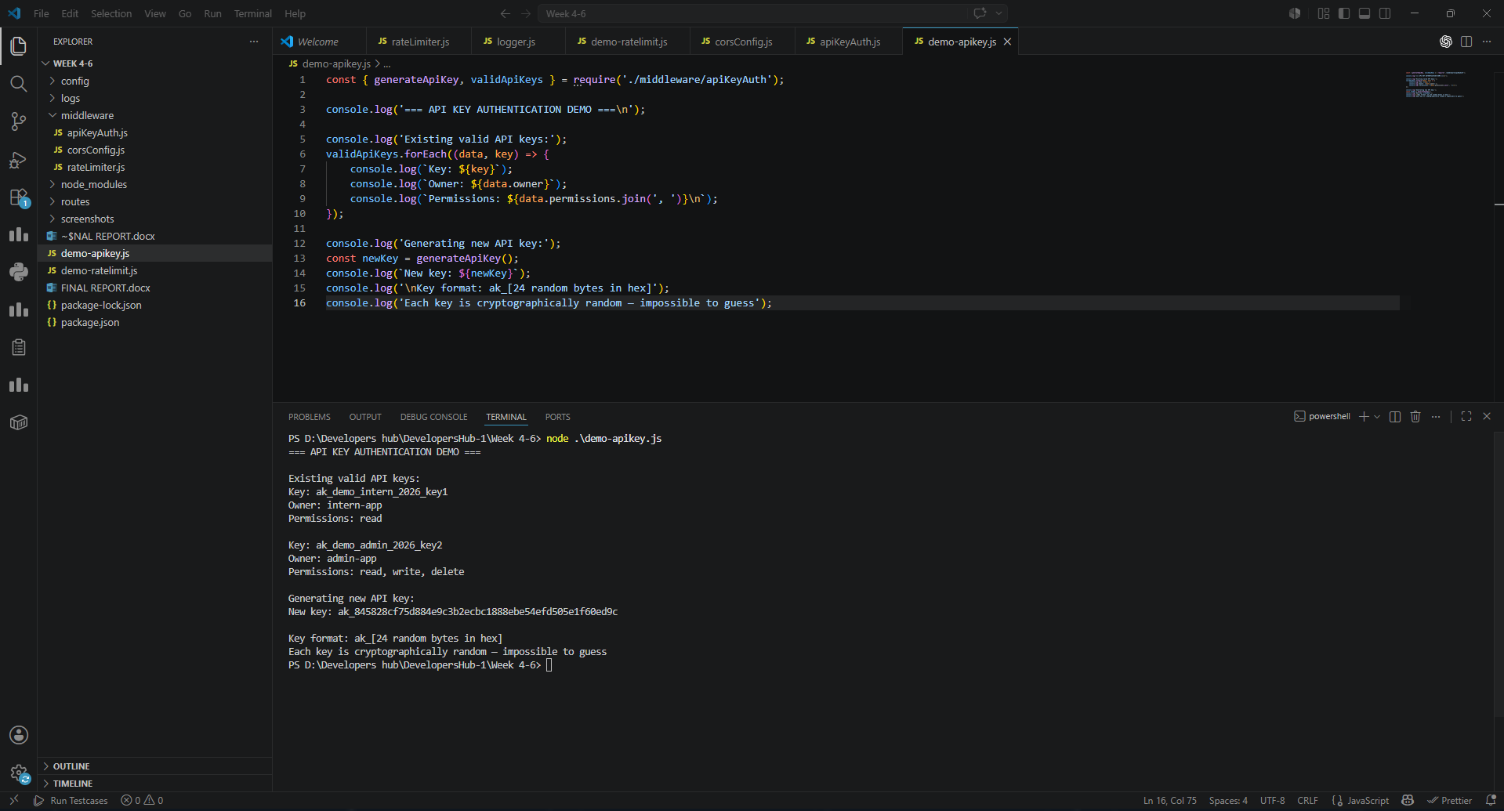

1.4 CSP & HSTS Implementation

File: middleware/advancedHeaders.js

Content Security Policy Directives:
- defaultSrc 'self': Only load resources from same origin
- scriptSrc: Blocks all inline scripts (main XSS vector)
- objectSrc 'none': Blocks Flash and all plugins
- frameAncestors 'none': Prevents clickjacking via iframes
- upgradeInsecureRequests: Forces HTTP → HTTPS automatically
- formAction 'self': Forms cannot submit to external domains

HSTS Configuration:
- maxAge: 31536000 (1 year) — browser remembers to use HTTPS
- includeSubDomains: Applies to all subdomains
- preload: Submitted to browser HSTS preload list
